



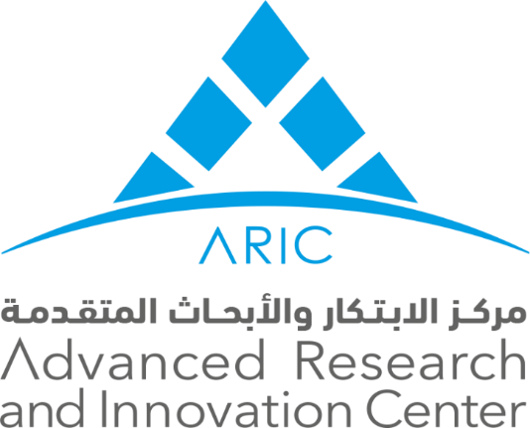

Vision, Mission, Aim and Objectives

Vision

Our vision is to become a regional and global leader in the research, development, demonstration and deployment of advanced manufacturing, and health and energy technologies.

Mission

Our mission is to develop research, human capital and technology innovation that underpin the UAE’s manufacturing, health and energy sectors. We are committed to bridging the gap between academia and industry through the development and deployment of solutions that address real-world challenges and needs.

Aim

To Put Innovation into Practice and Create A Competitive Edge in the Advanced Industries

Objectives

- To identify technologies that have the potential to create transform the manufacturing, health and energy sectors.
- To support UAE industries in their efforts to develop innovative technology solutions for manufacturing, health and energy.
- To educate and train students in the design and manufacture of advanced technologies.

